Note : Share live tracking with others with riders details

Step 1: Sign Up

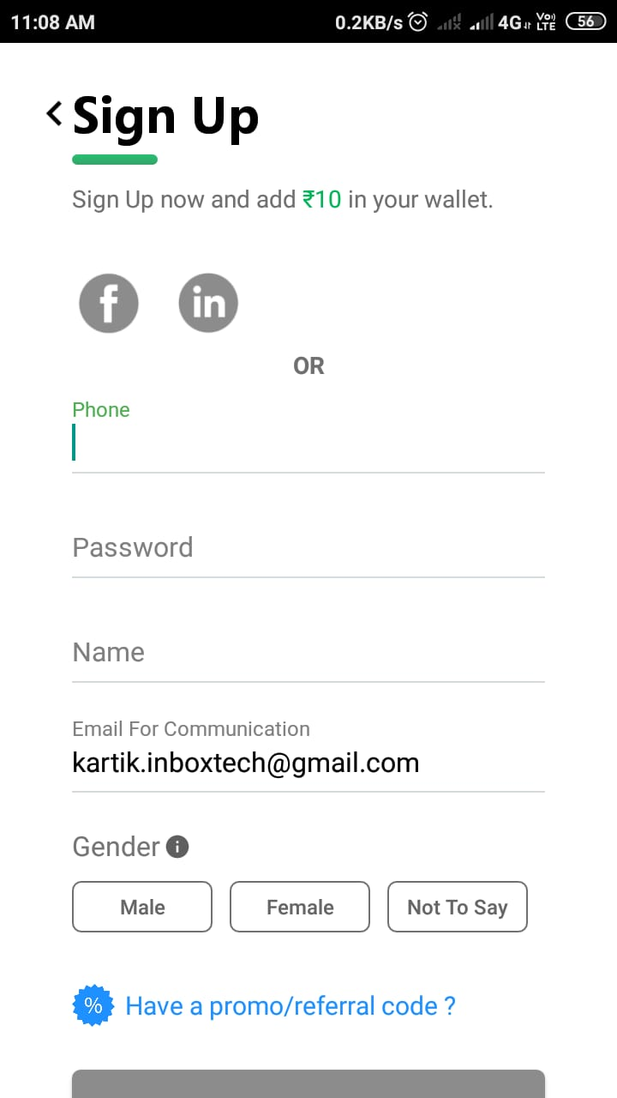

Field :

Profession . example – Plumber, Doctor etc.

Step-2: after Add your vehicle details

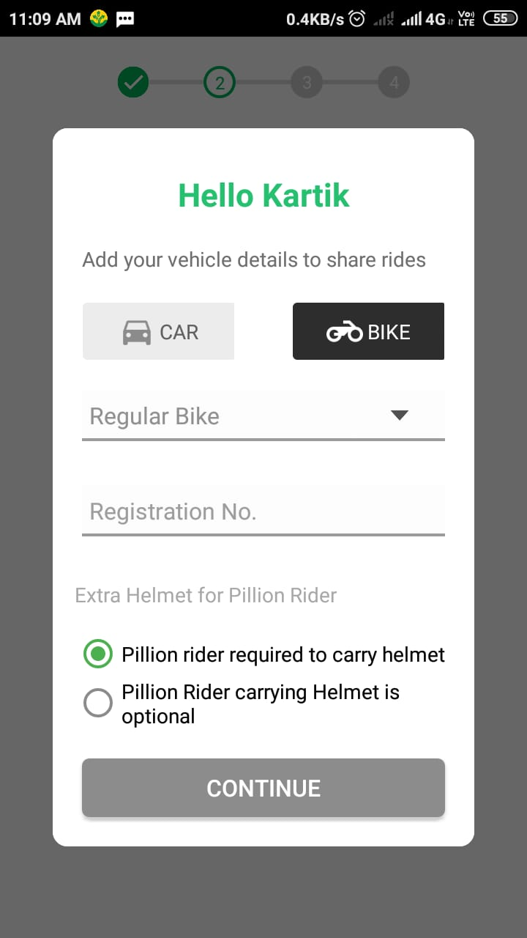

1. Car : types of car (Ex. Sedan,SUV) And give your car registration No.

2. Bike : types of bike(Ex. Sports bike,Regular bike) And give your bike registration No. and click continue

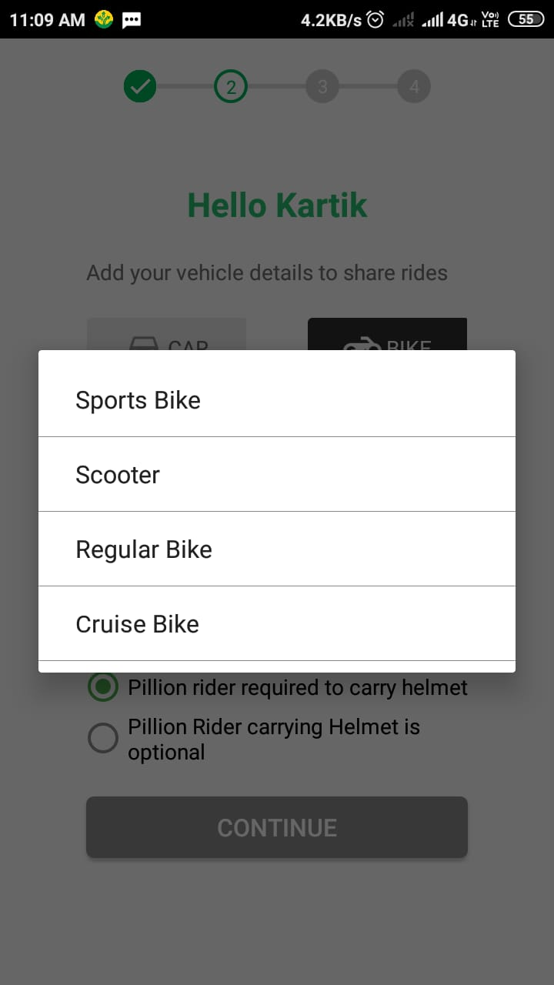

Step-3:Details of your Ride.

Find Rides for your Route

* Select Route from Home to Office and Office to Home.

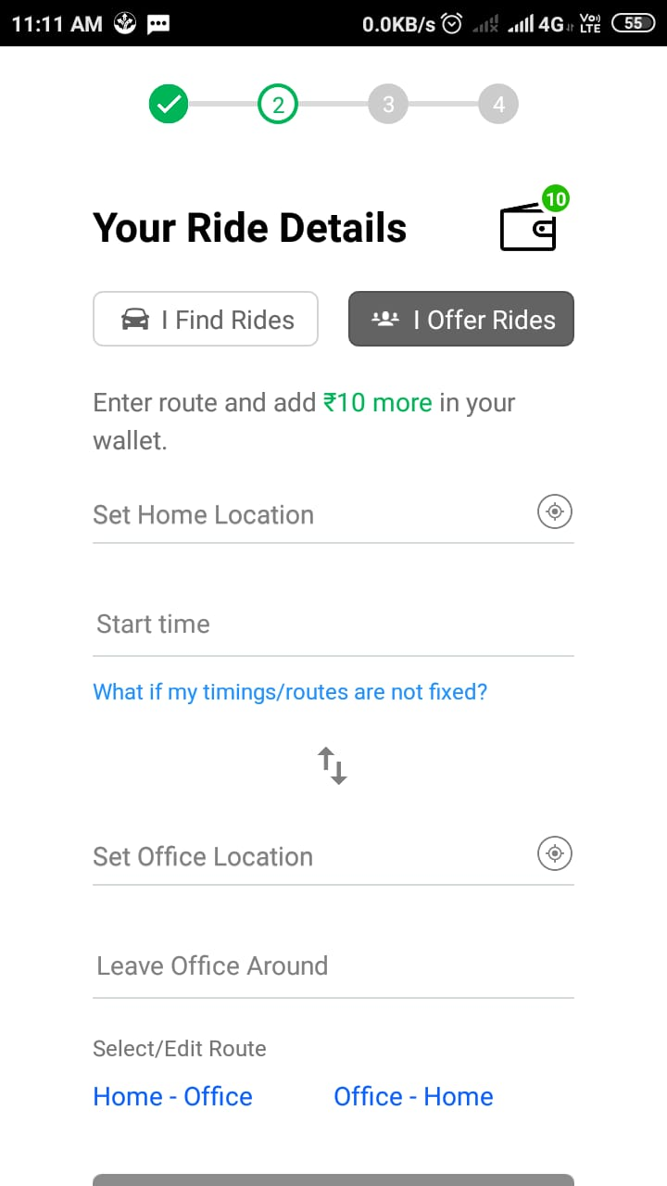

Step-4 : Email Verification for User

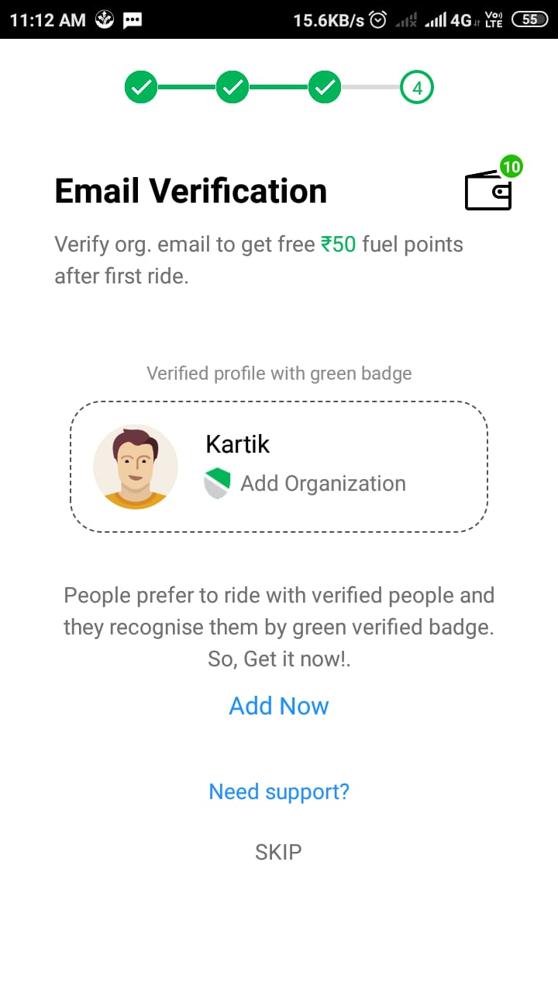

Step-5:

Screen-1: New Ride

after click skip or Add Now button after find your ride .

* Enter your starting to end address for ride
* After select date and time for ride and click find ride button.

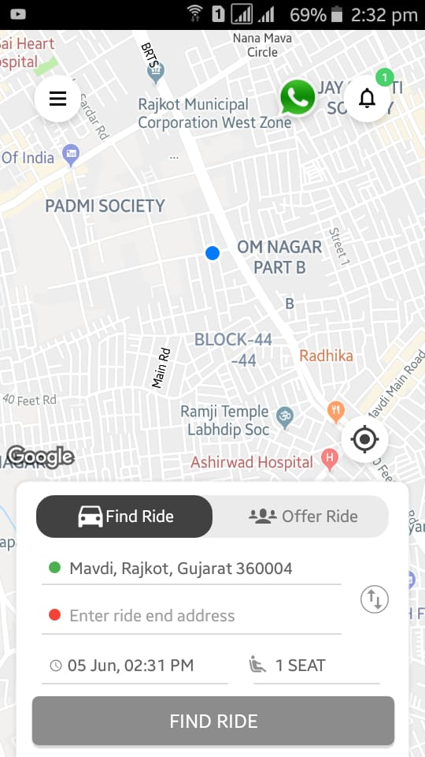

Step-6: after click find ride button that finding for rider then rider is not found that time open popbox to no rider is available right now.

And then click option for find ride

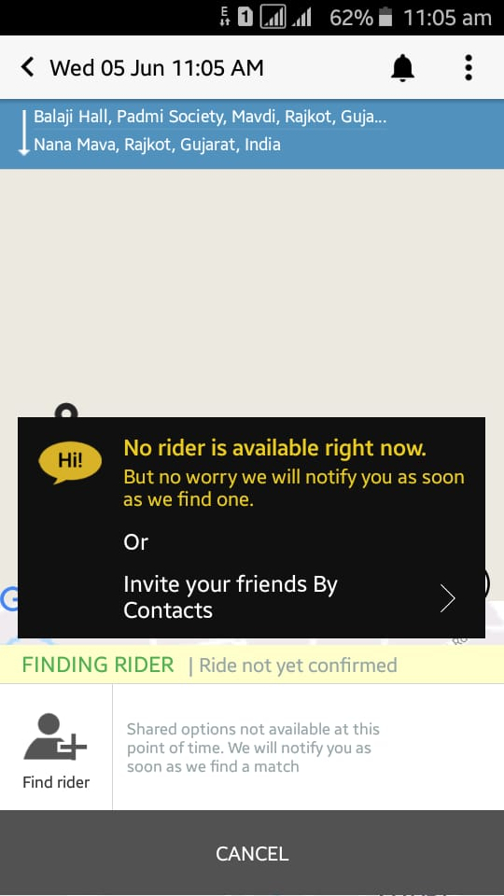

Step-7: click find rider button show four option riders,Favourites,Groups,Contacts.

Riders: You can Ride with verify users.

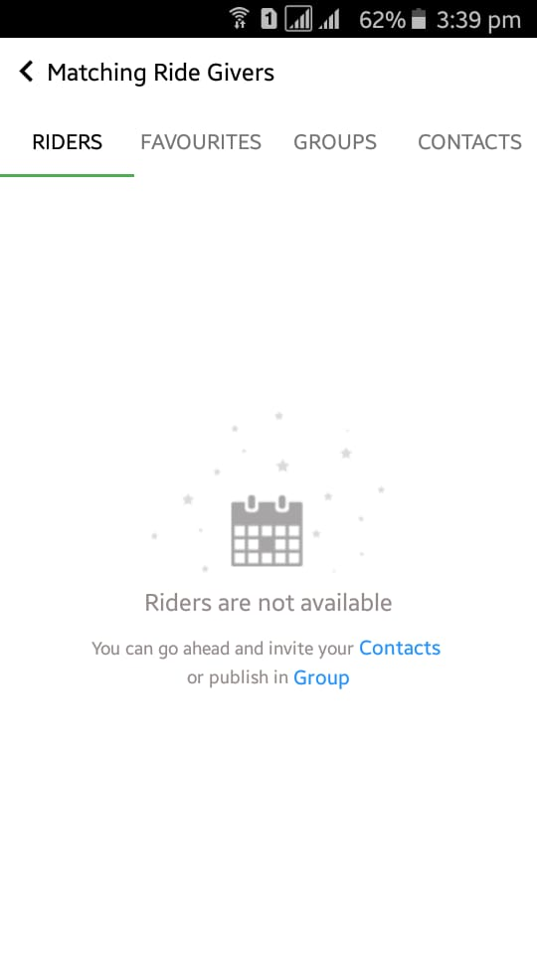

Favourites :

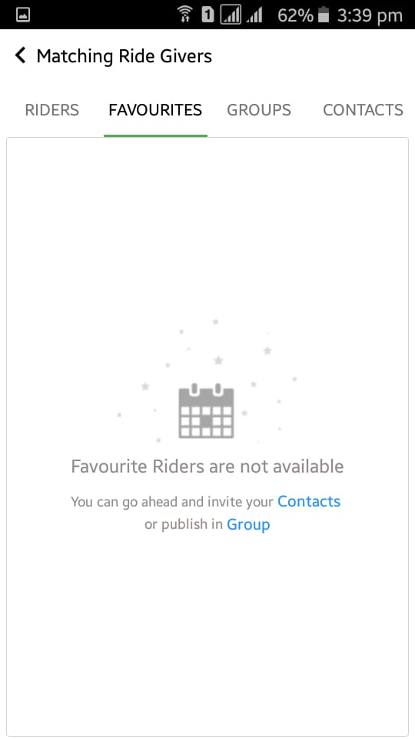

Group: You can create new group for this route

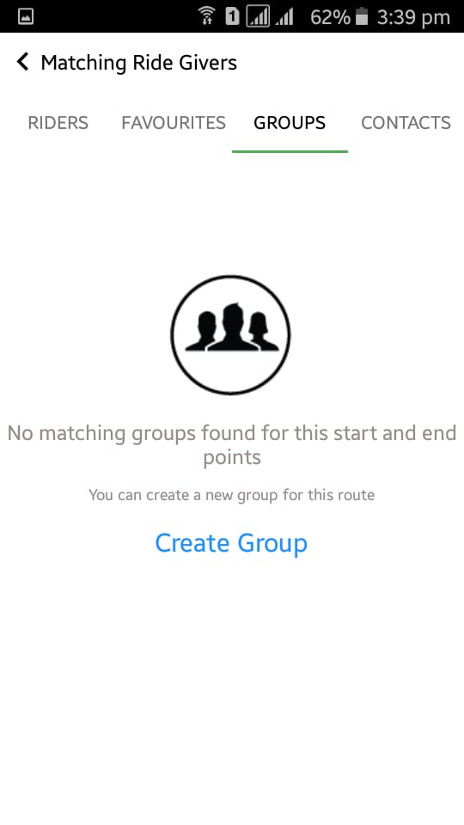

Contacts : You can select your contact list.if user are unverified then open pop-up box & give msgare you sure,you want to share ride with unverified user.click yes then go to next step.

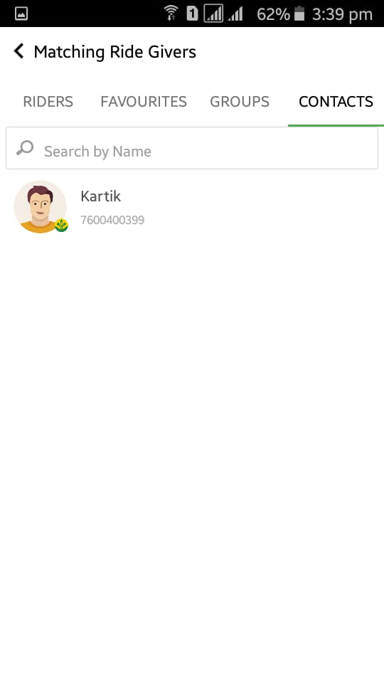

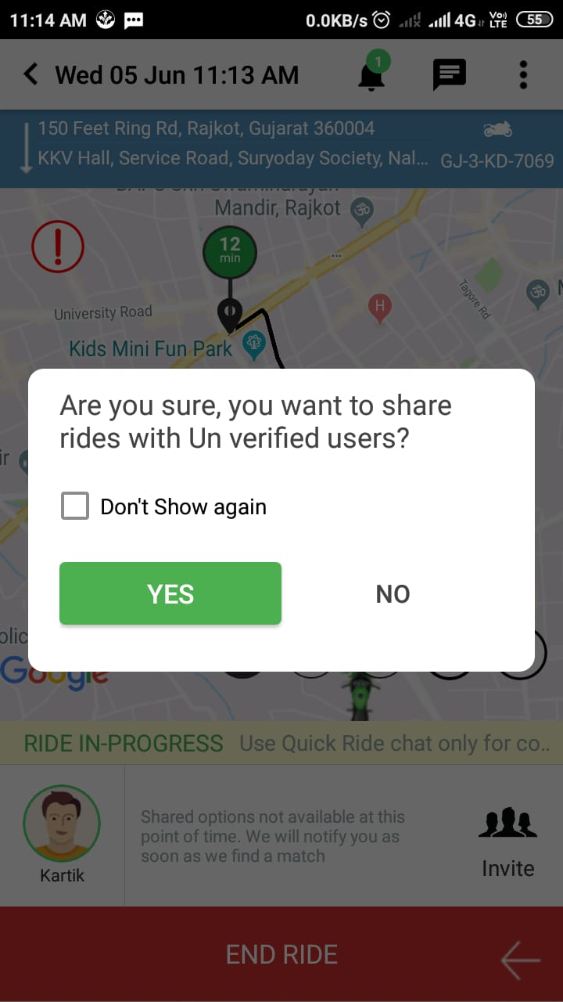

Step -9: after if rider is available than you can see live ride view.

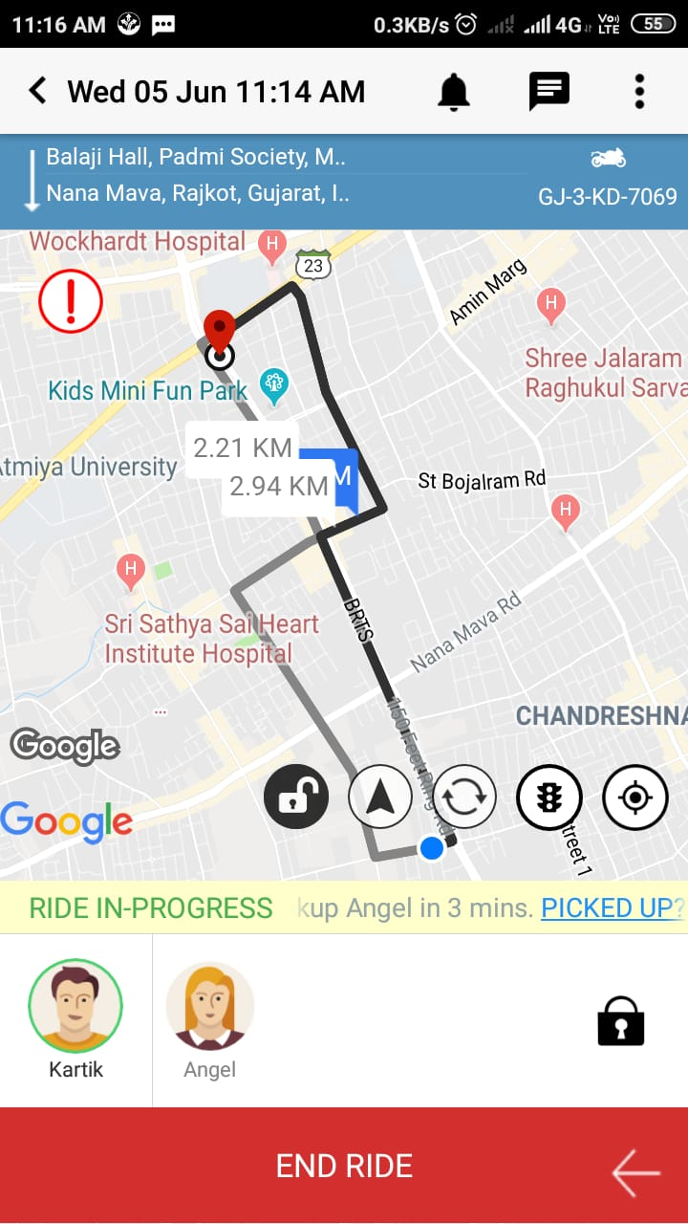

And after user join ride pop up box is open and give message user join your ride for this location

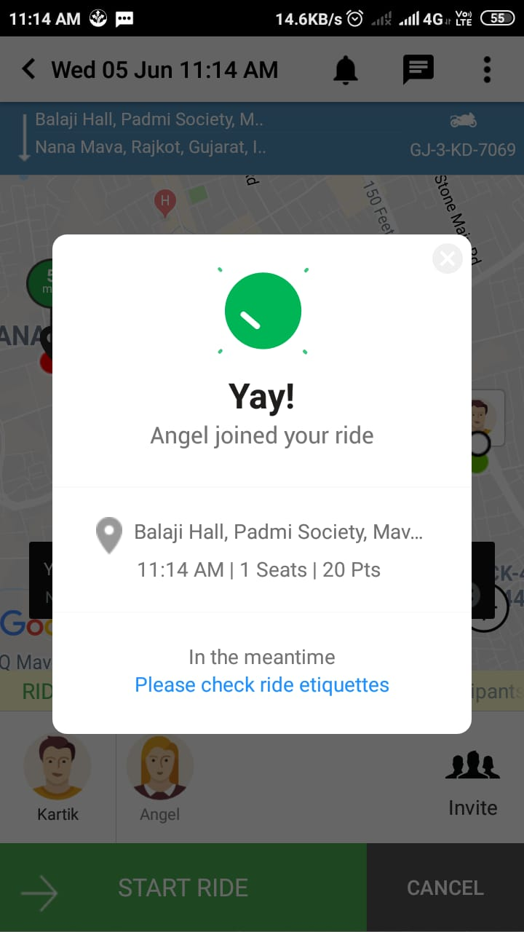

When you reach your destination that time give a message your ride is completed.

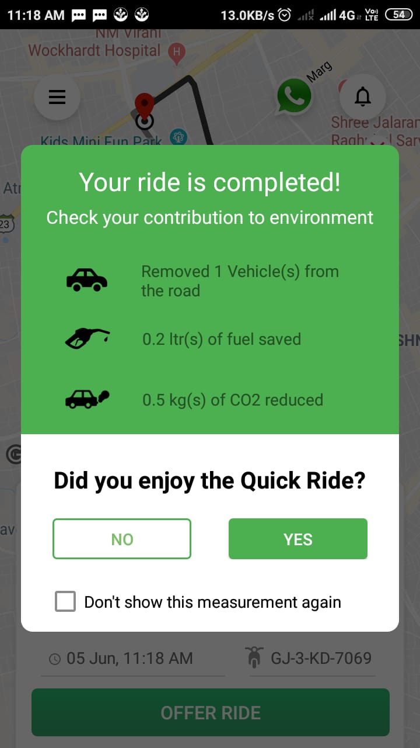

User Feedback :

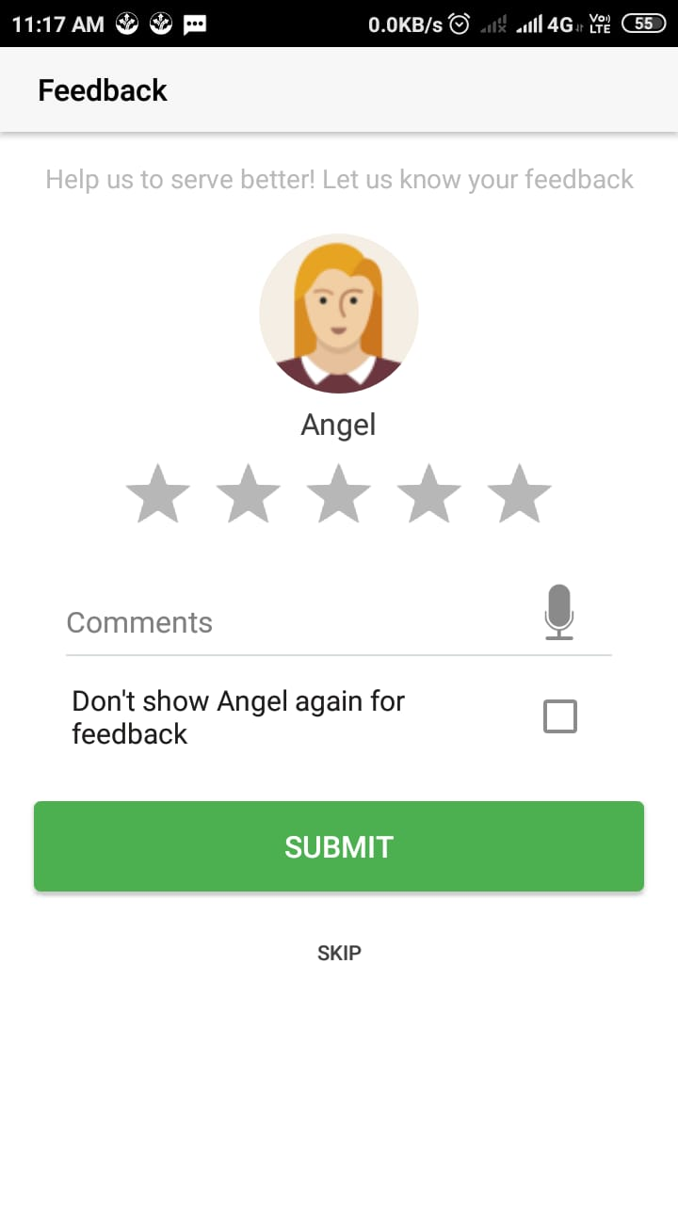

Trip Report :

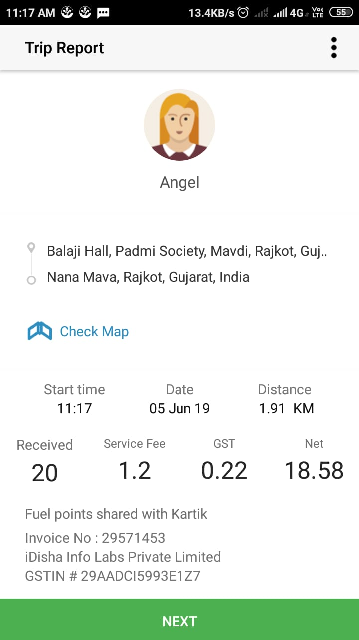

Notification :

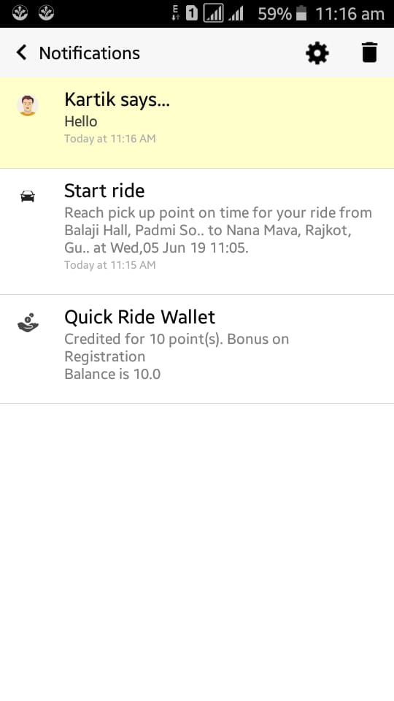

Step-10: click offer ride button,get offer for free ride.

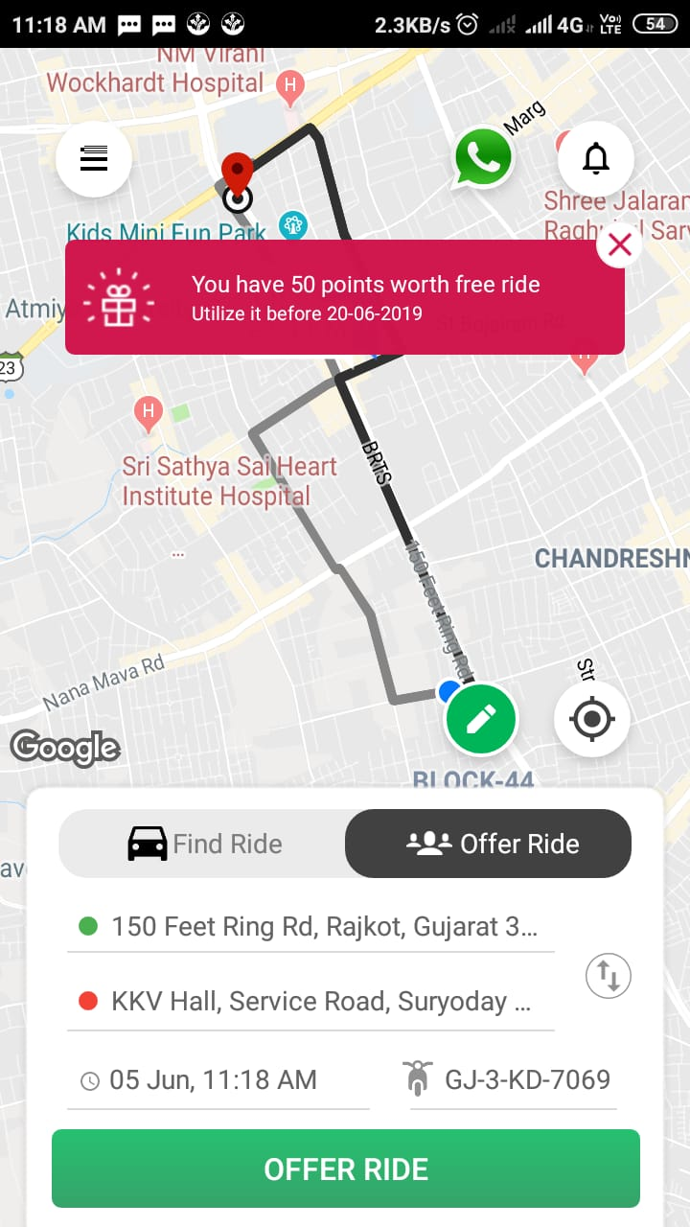

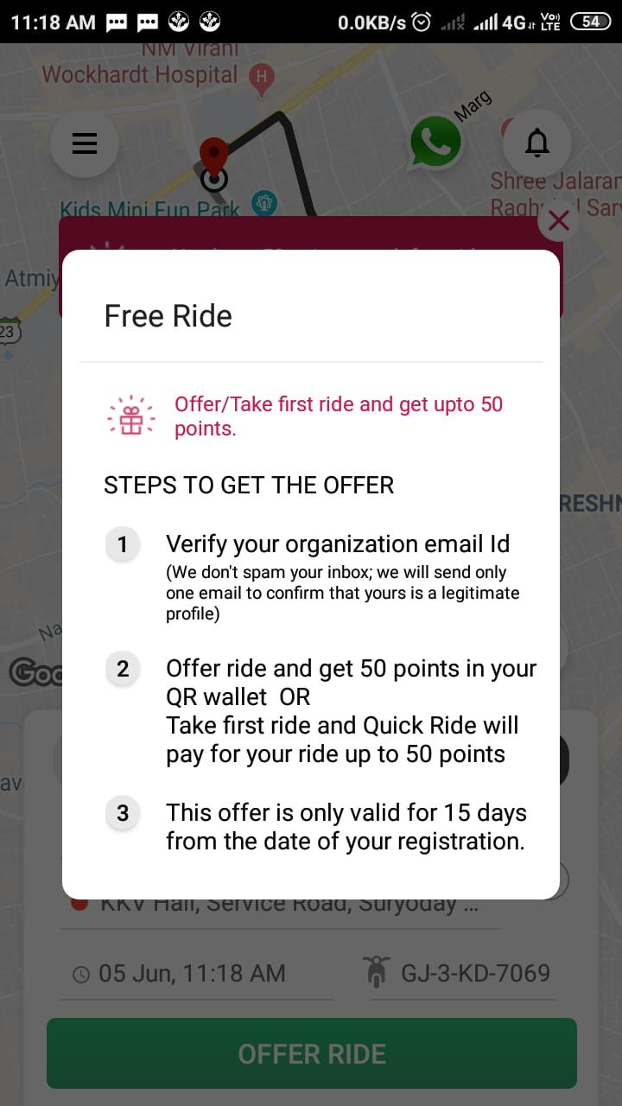

Step-11:

Screen-2: My Rides

* Upcoming :Whenever you join any ride it will list here

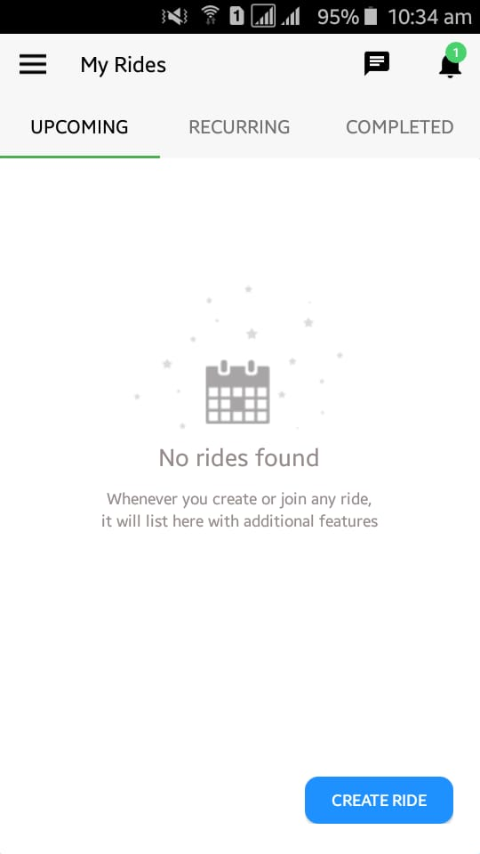

* Recurring : Whenever you create Repeat ride it will list here

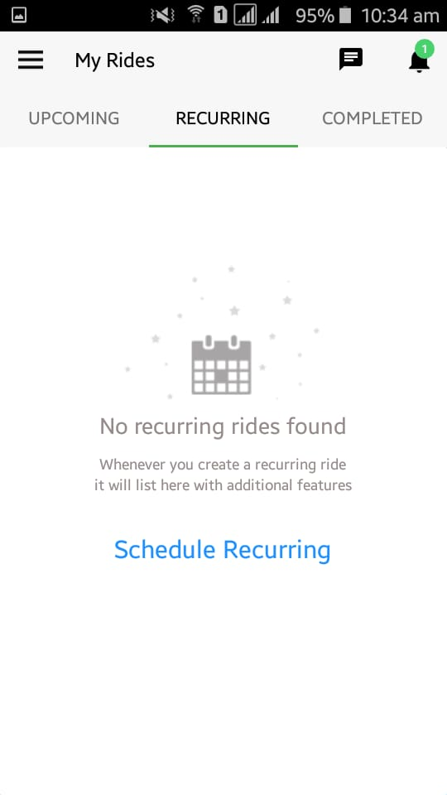

* Completed : Whenever you create a complete and cancel ride.it will list here

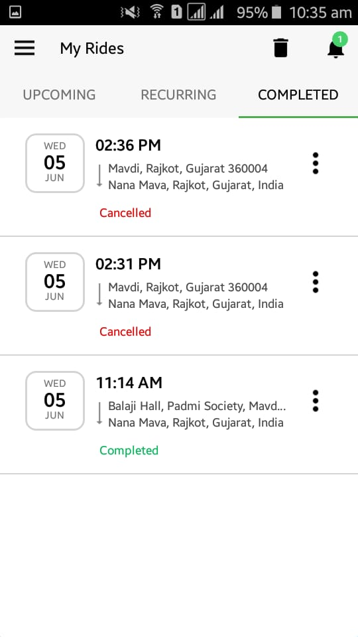

Step-12:

Screen-3 :My vehicle

You can add your Vehicle in this screen.

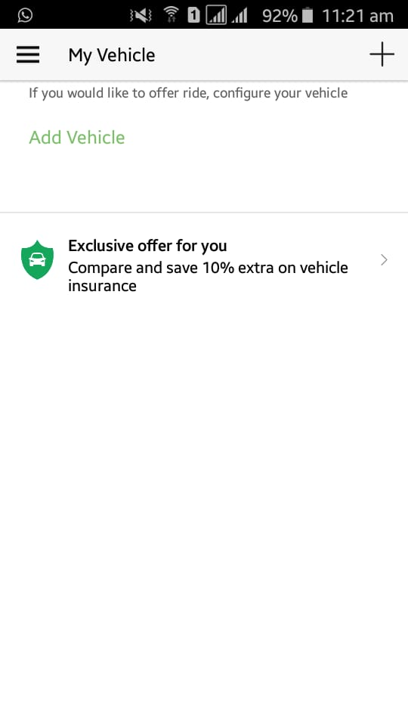

Click Add vehicle button. You can add details of your car and bike.

Details of your car or bike:

* Add your car or bike picture.
* Types of car(Ex. SUV,Sedan)
* Registration no of your car or bike.
* Fuel points
* Offering seats
* Category(Ex. White Swift)
* Feature( Ex. AC , Helmet)

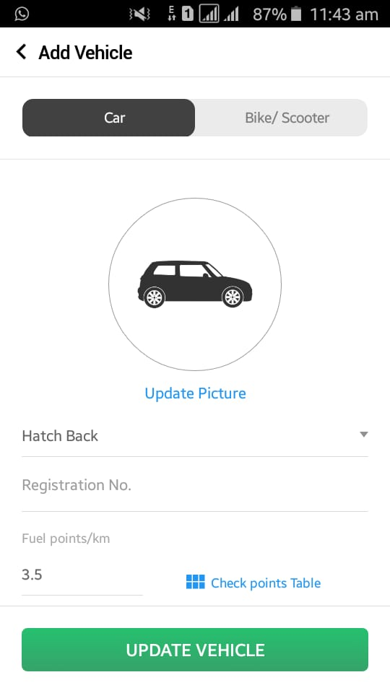

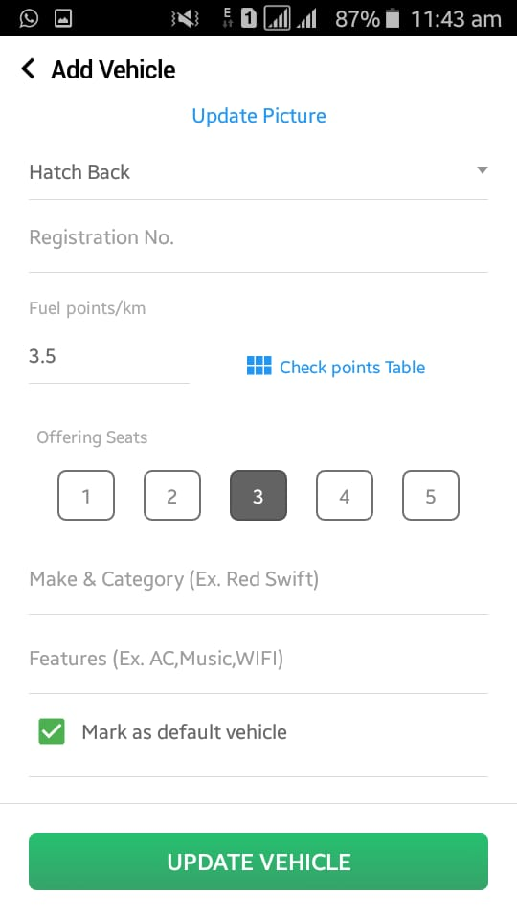

Step-12 :

Screen-4 : Chat

You can chat with your ride partner or chat with roup.

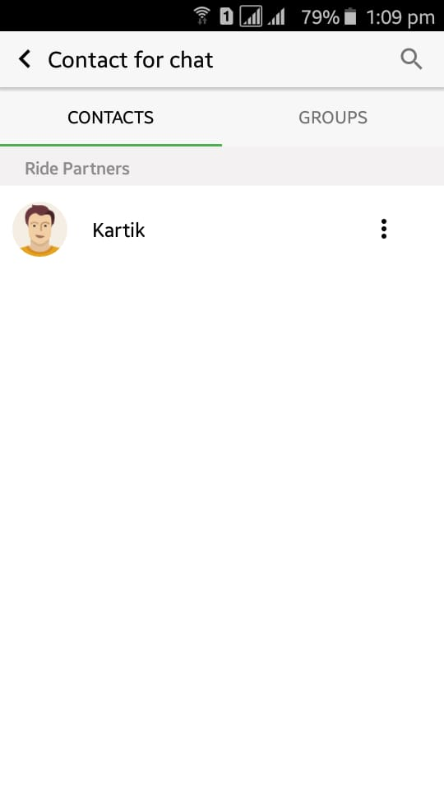

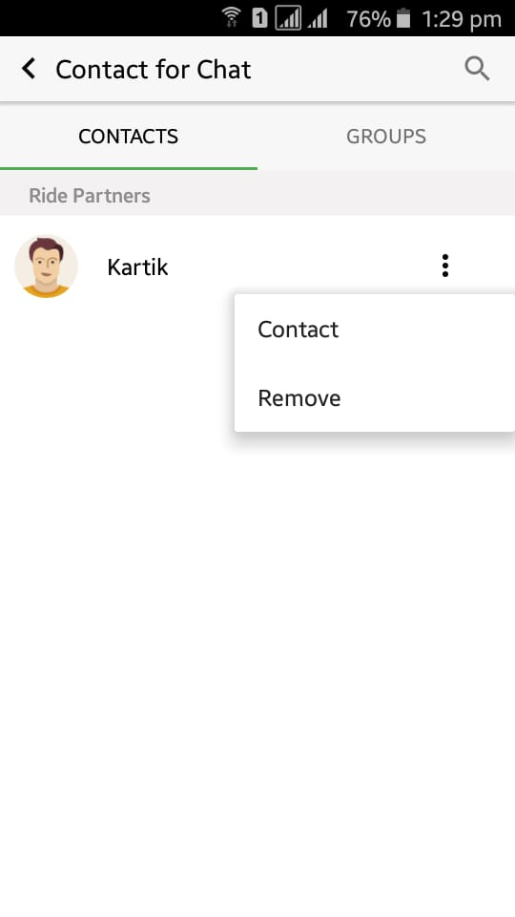

Click contact button,You can call,chat and SMS with your Ride partner.

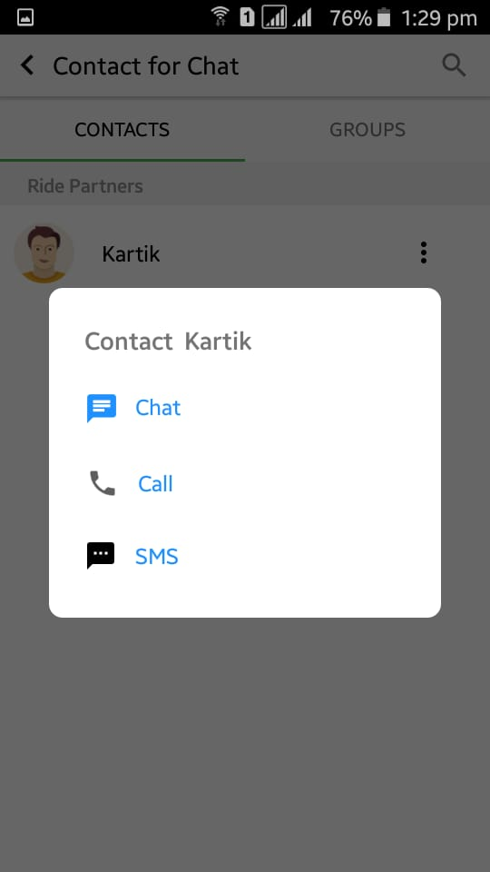

Step-13 :

Screen-5: My Groups

Youcan create a new Group.

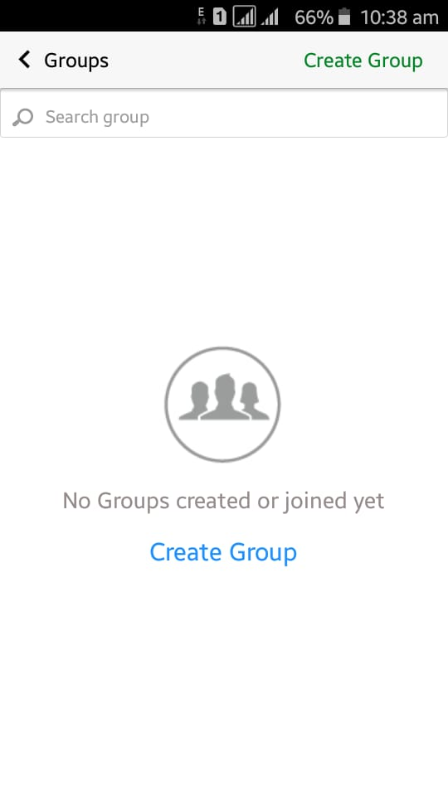

Click create group button,you can upload group profile,name,description,category,group type and set location.

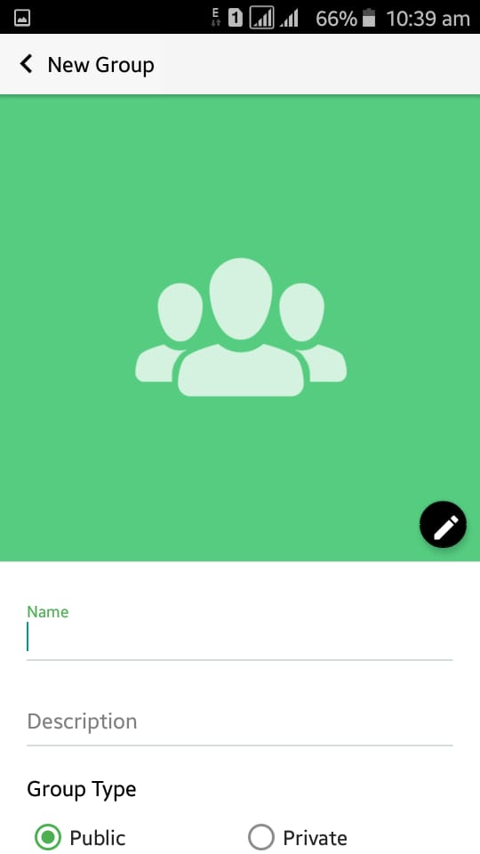

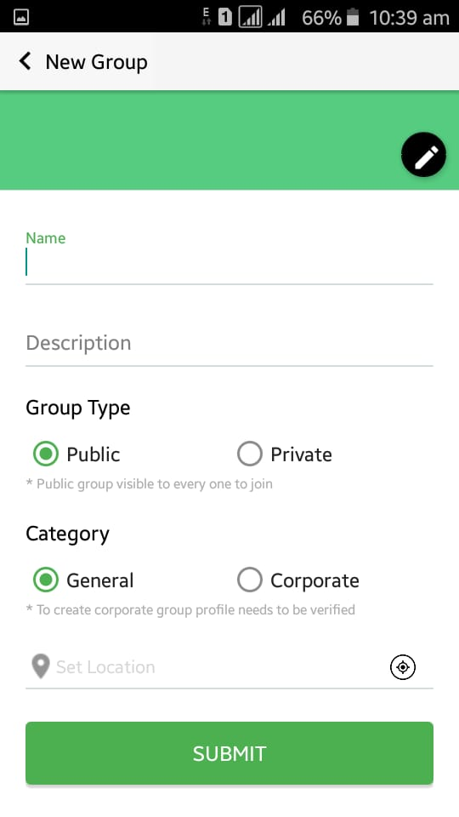

Step-14 :

Screen-6 : My Offers

Get offrers for user.

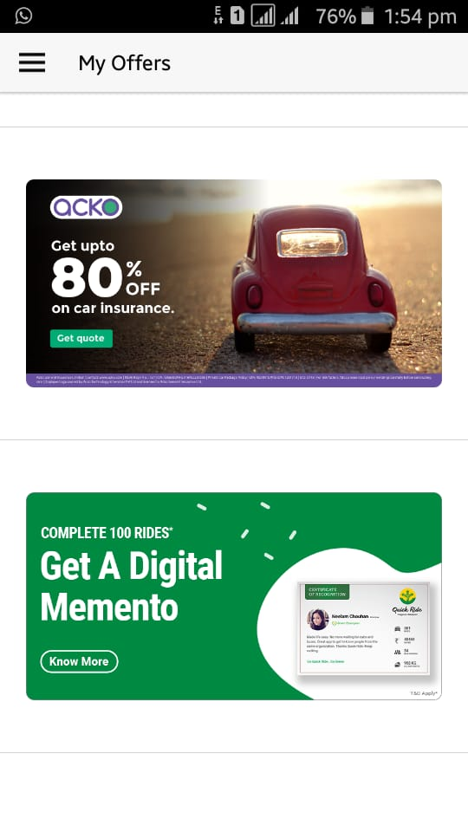

Step-15 :

Screen-7 : My Contribution

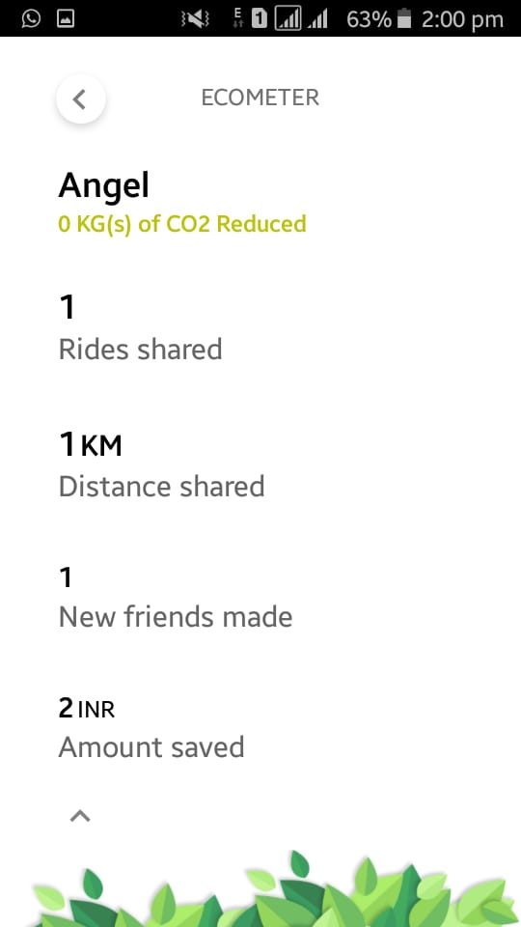

Step-16:

Screen-8 :My Payments

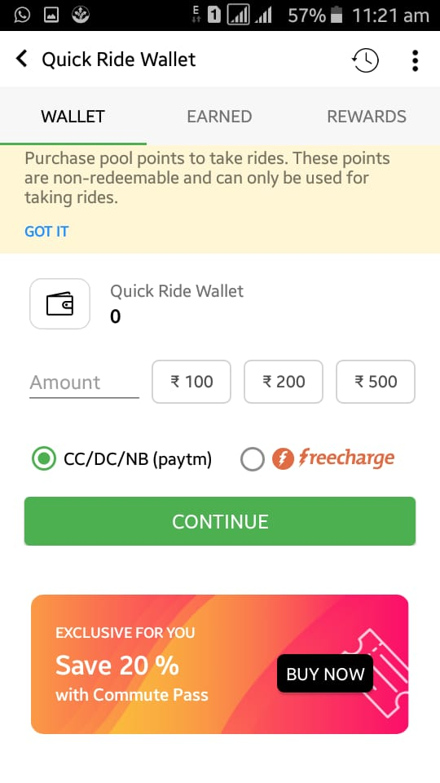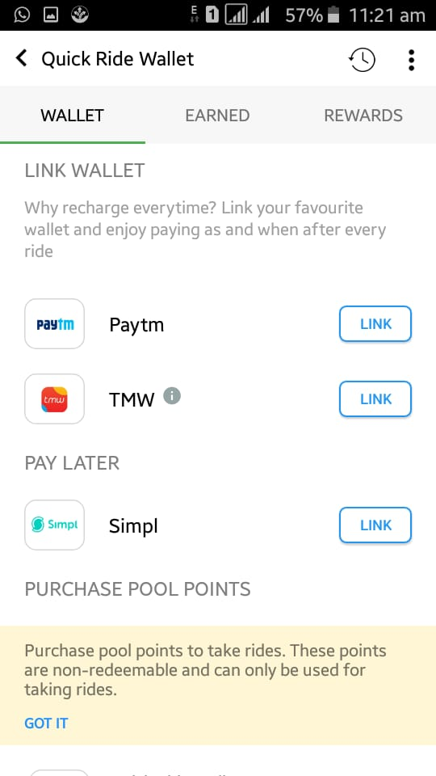

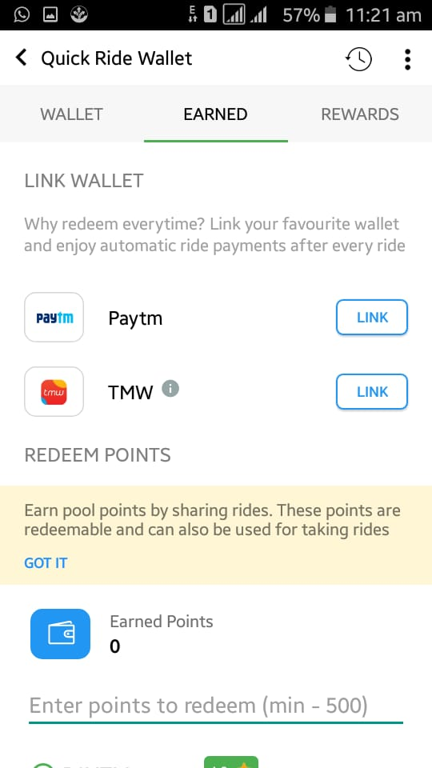

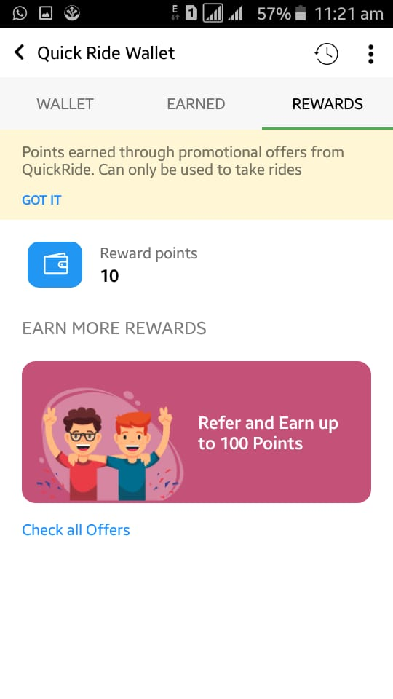

Step-17 :

Screen-9 :Settings

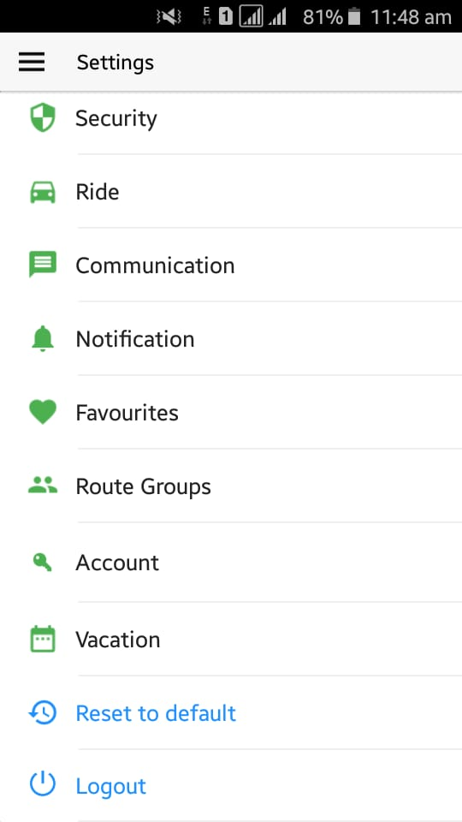

* Security :

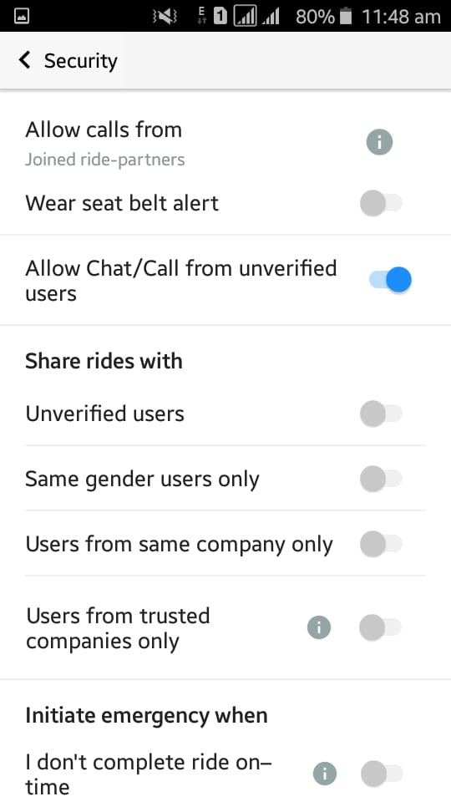

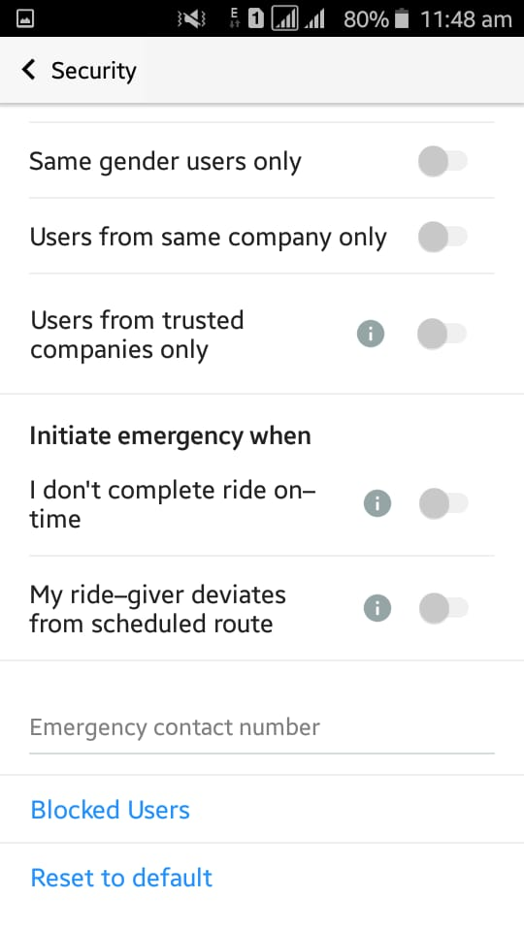

* Ride :

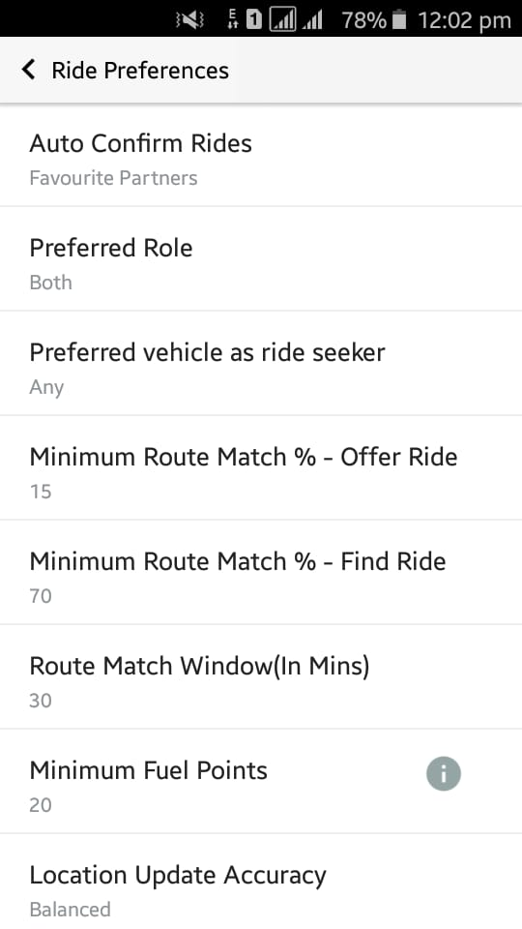

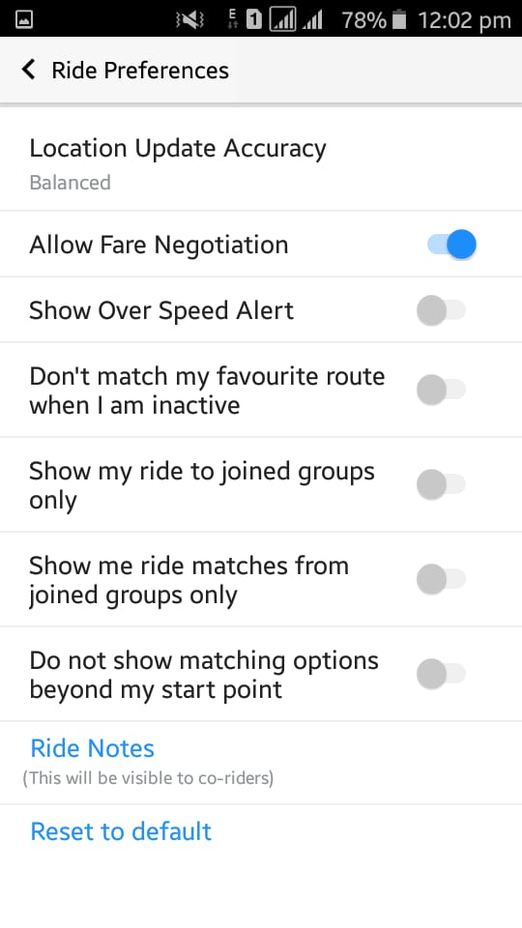

1. Auto Confirm Rides :

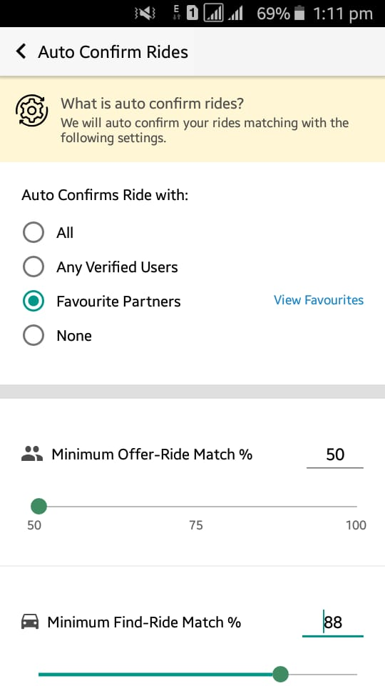

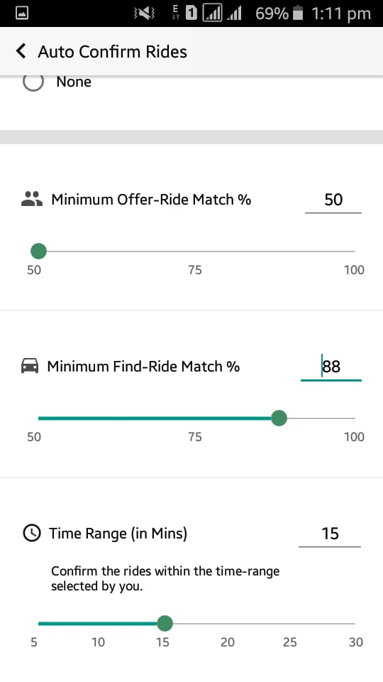

1. Preferred role :

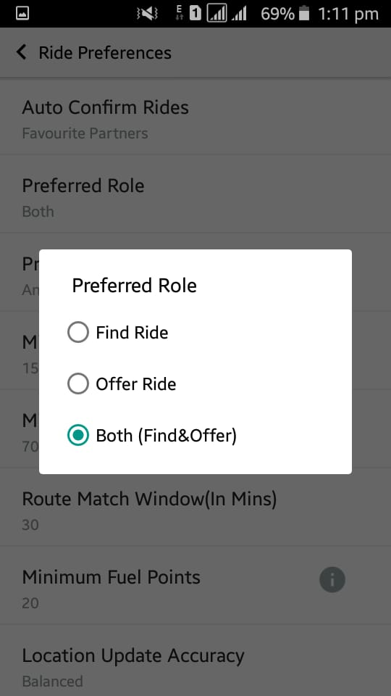

1. Preferred vehicle :

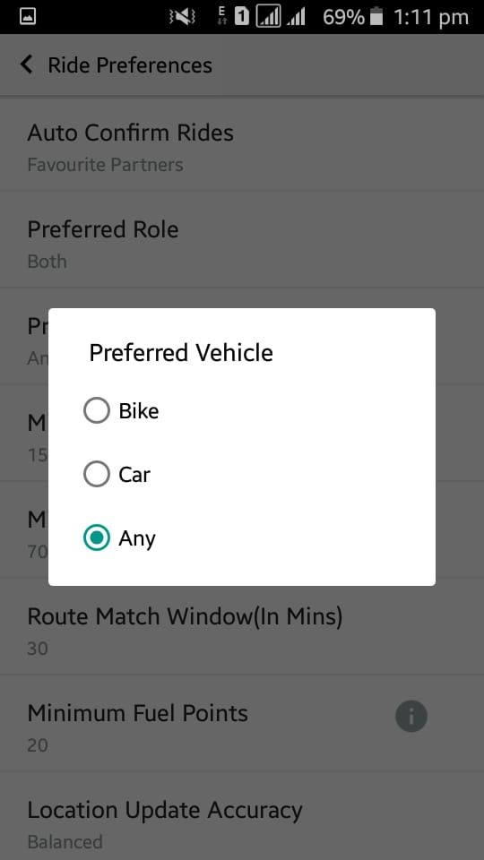

1. Minimum route match-offer ride

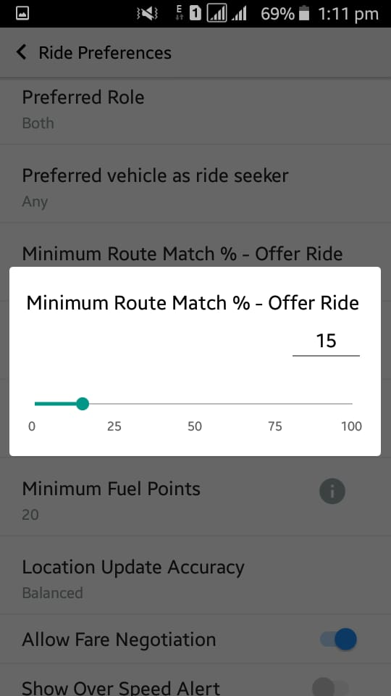

1. Minimum route match –find ride

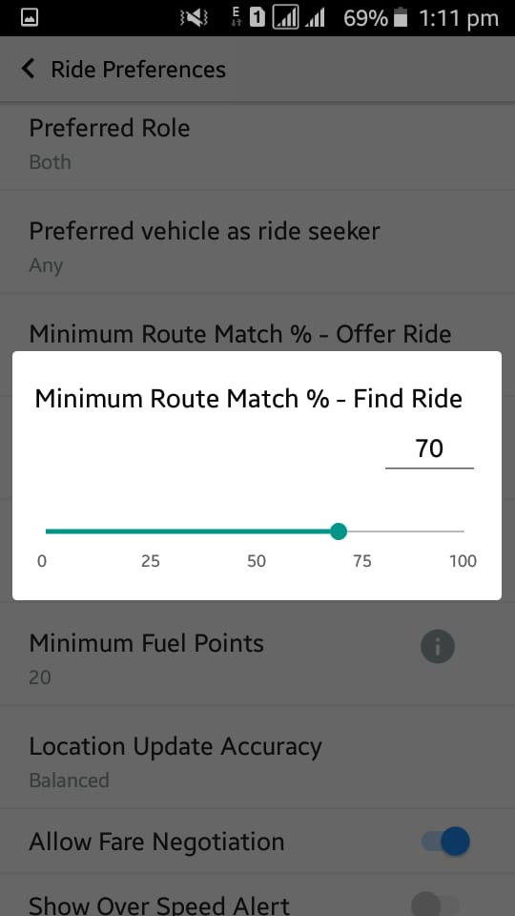

1. Route Match Window :

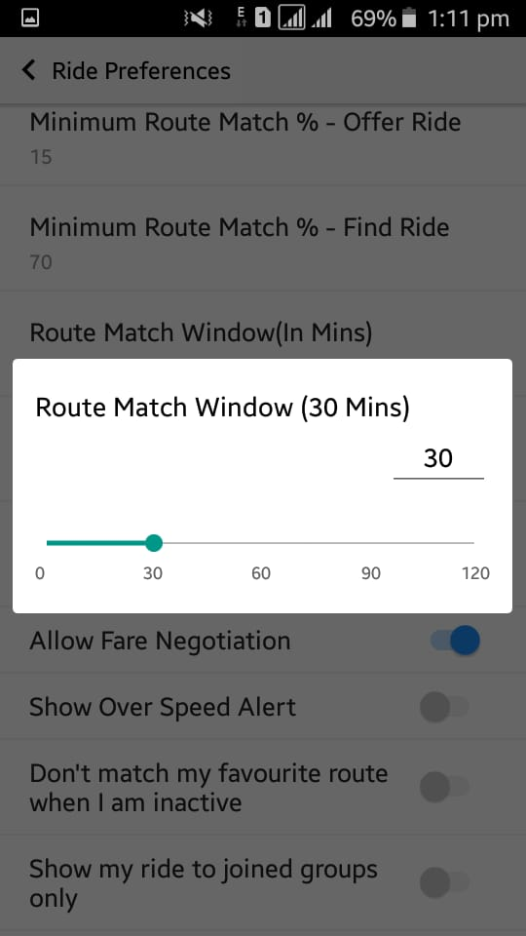

1. Fuel Points :

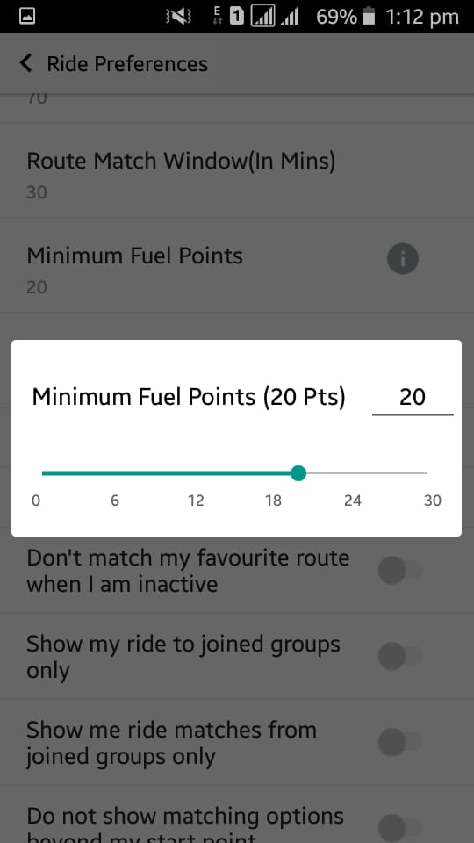

1. Location update Accuracy :

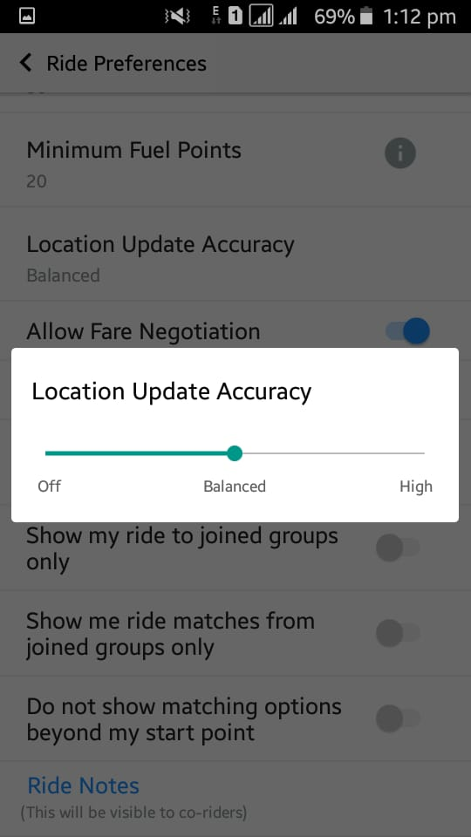

1. Ride notes :

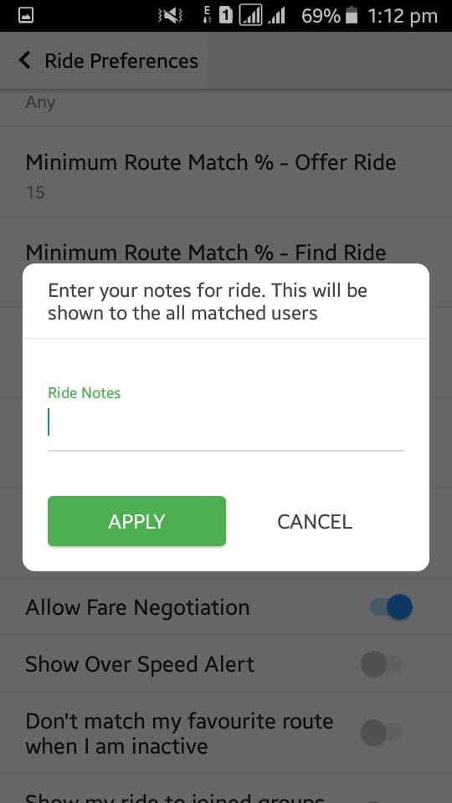

* Communication :

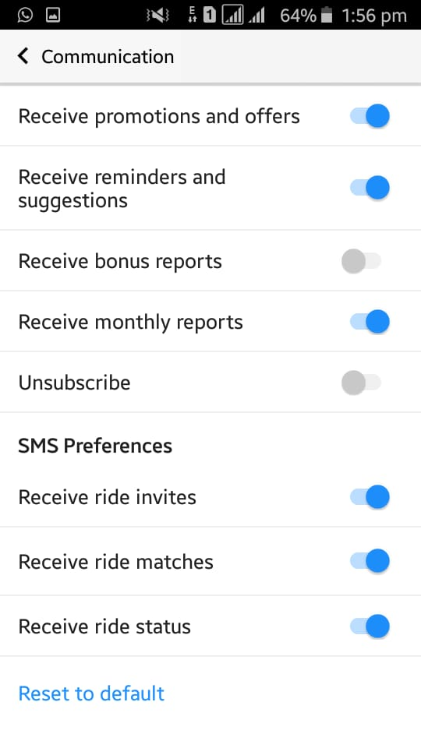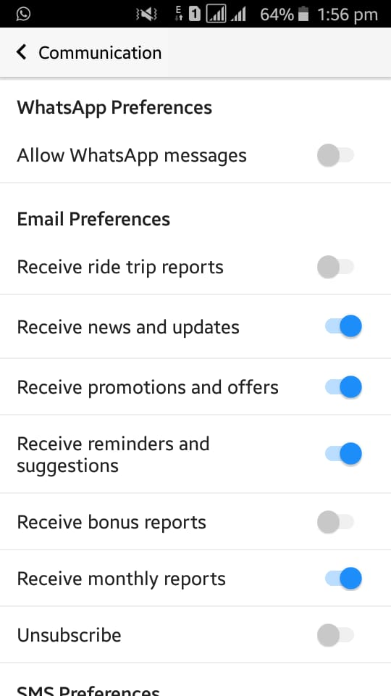

* Notification :

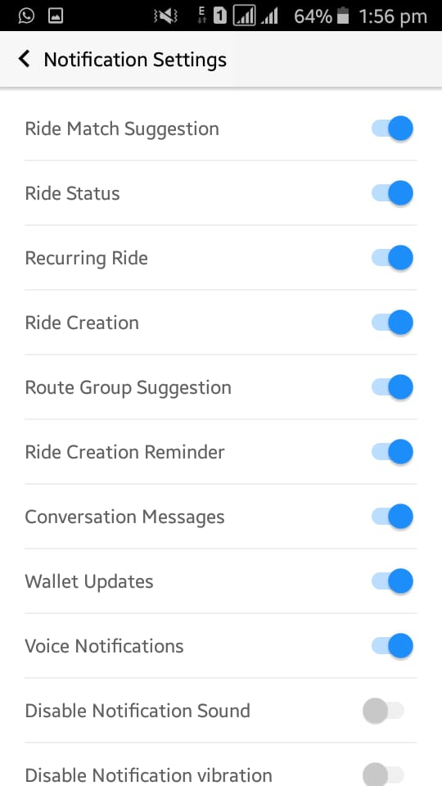

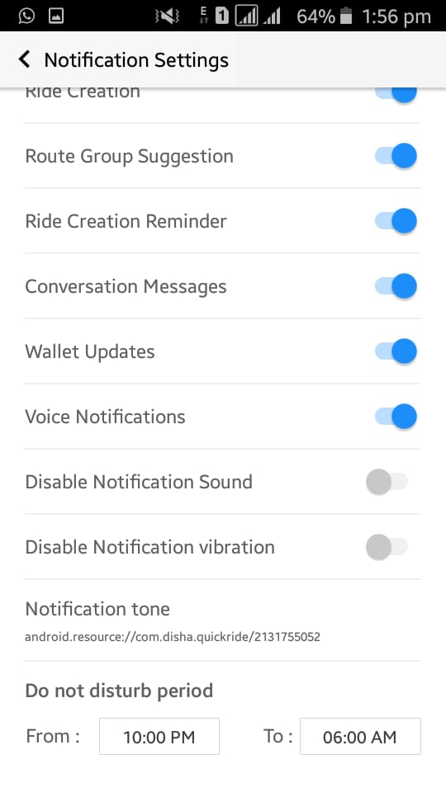

* Favourites :

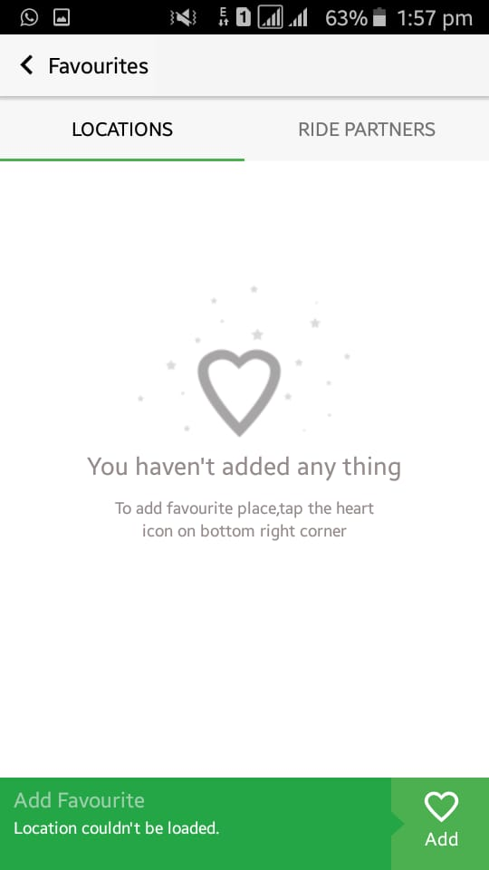

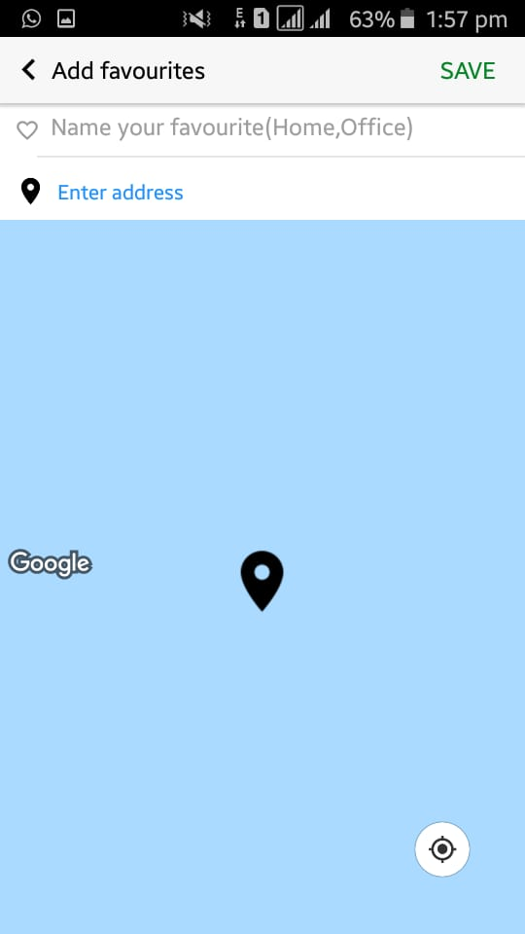

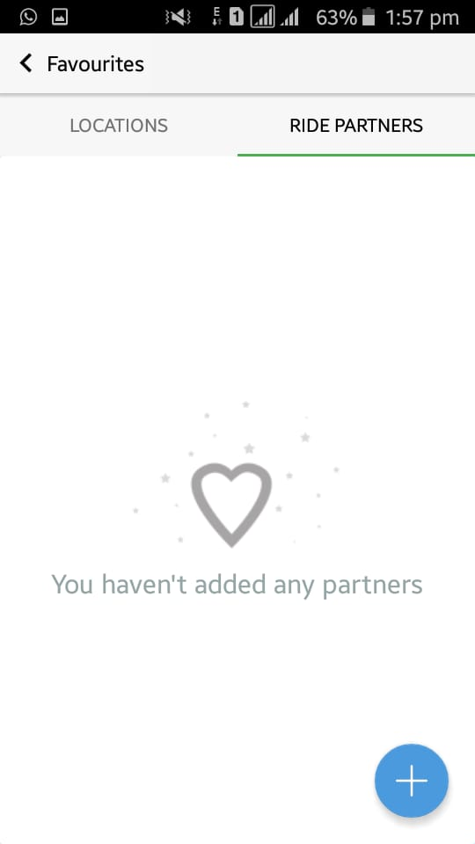

* Route Groups :

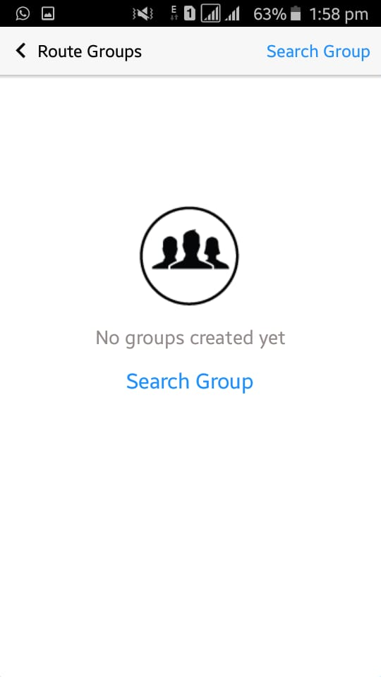

* Account :

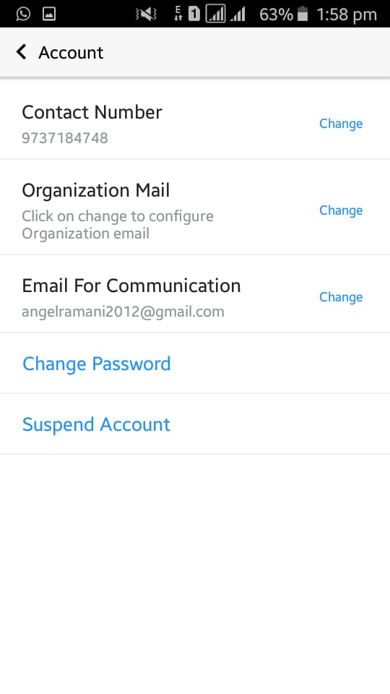

Change Contact no:

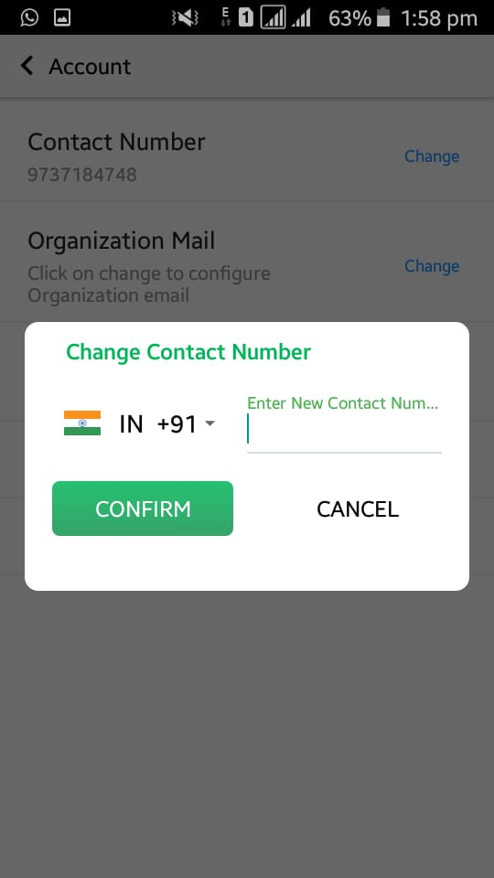

Change Organization Mail :

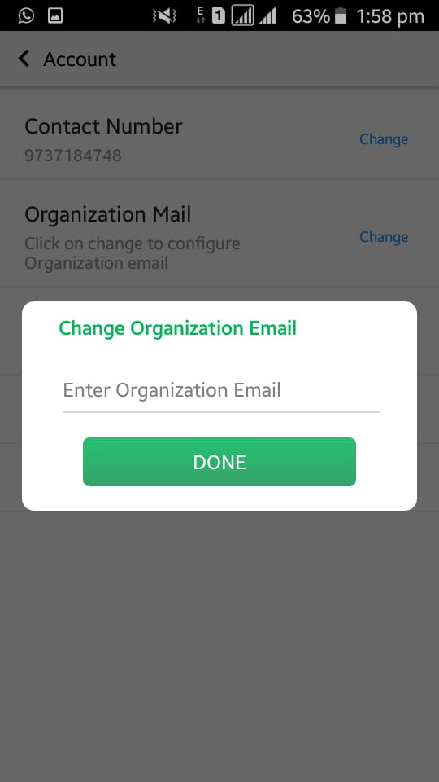

Change Email :

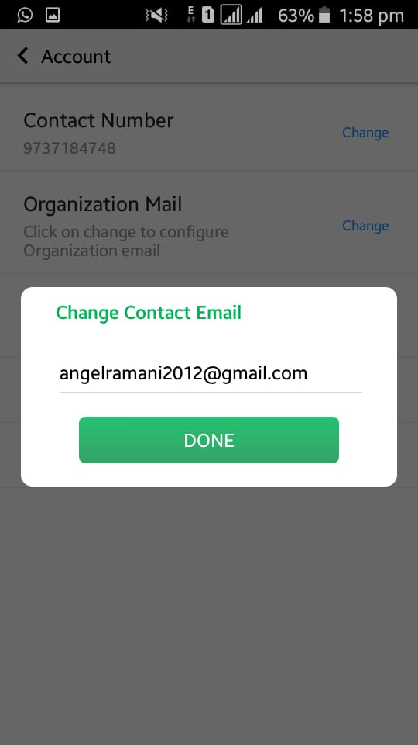

Change Password:

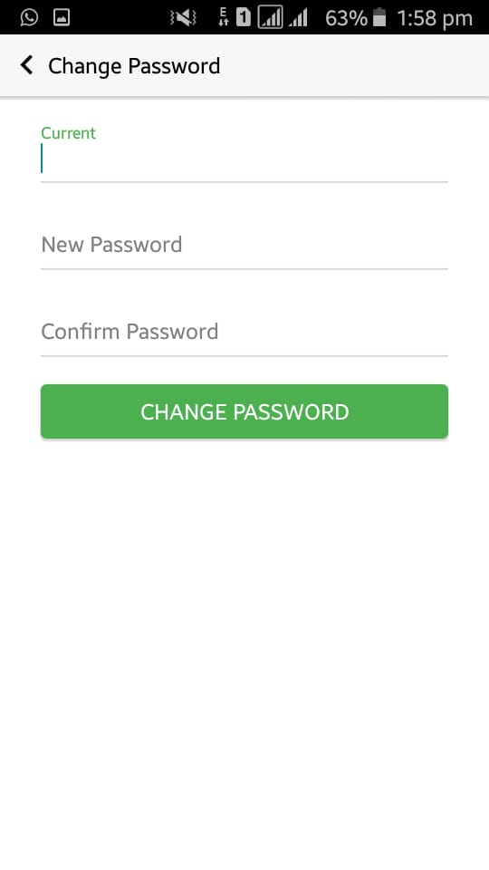

Suspend Account :

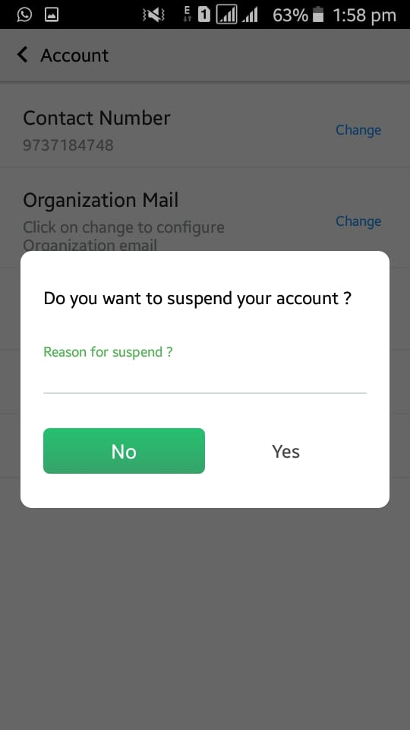

* Vacation :

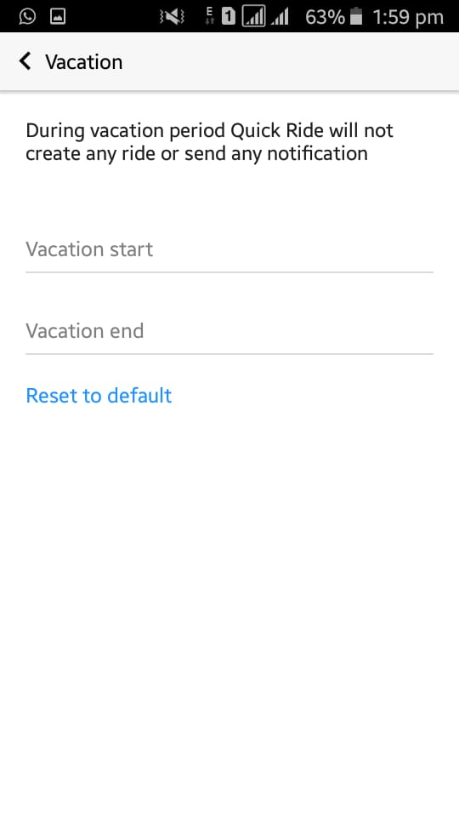

* Log out :

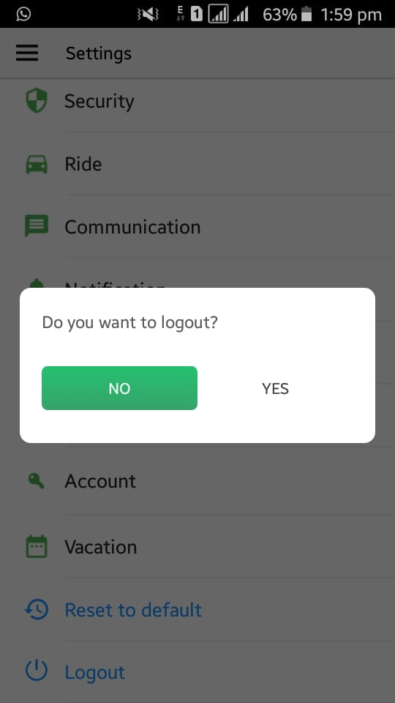

* Refer & Earn :

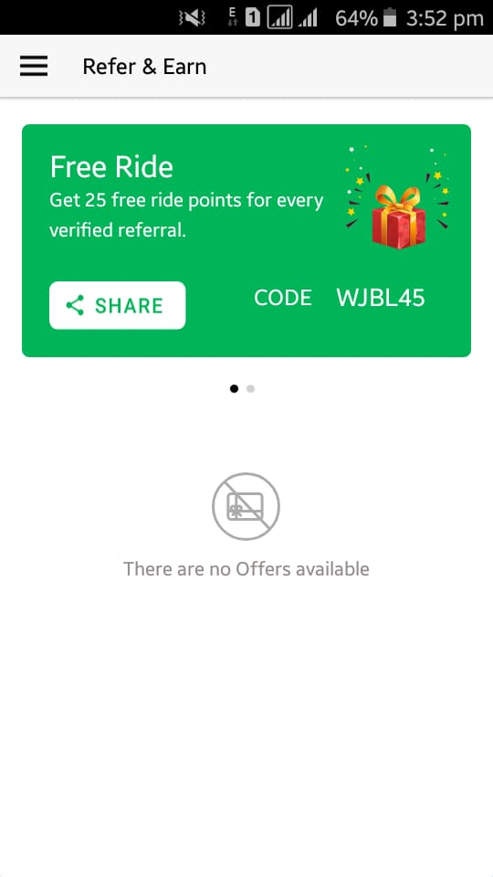

* Profile :

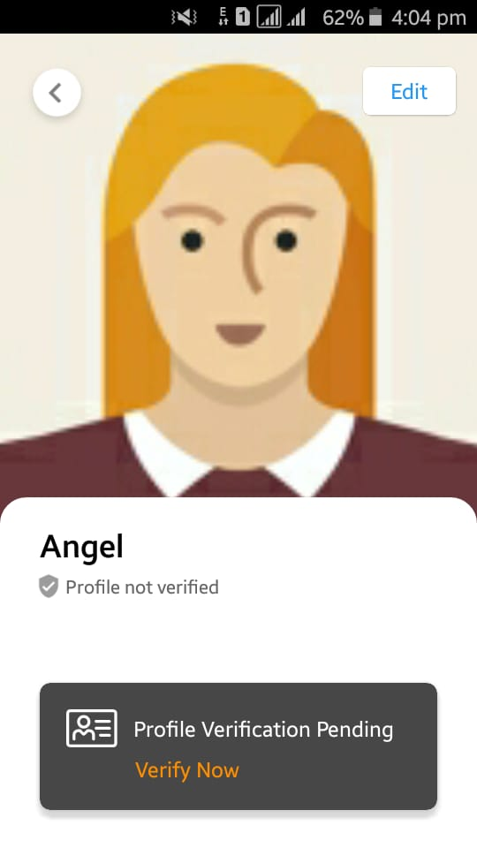

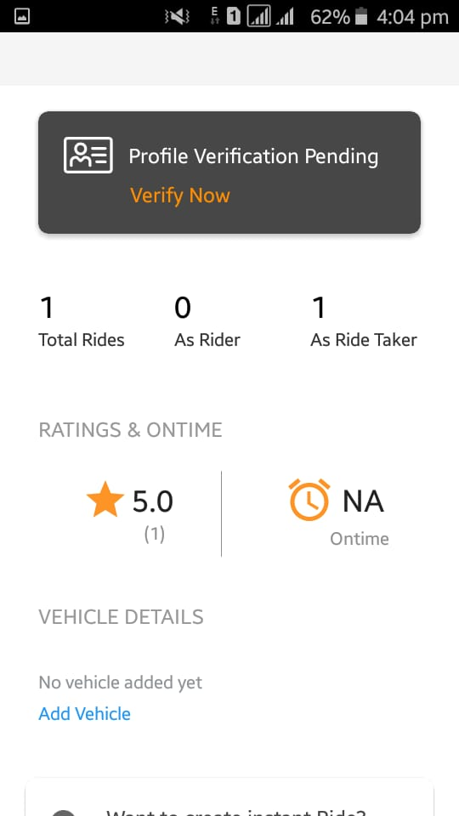

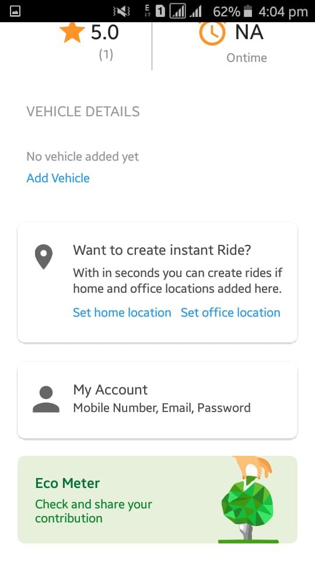

* Edit Profile :

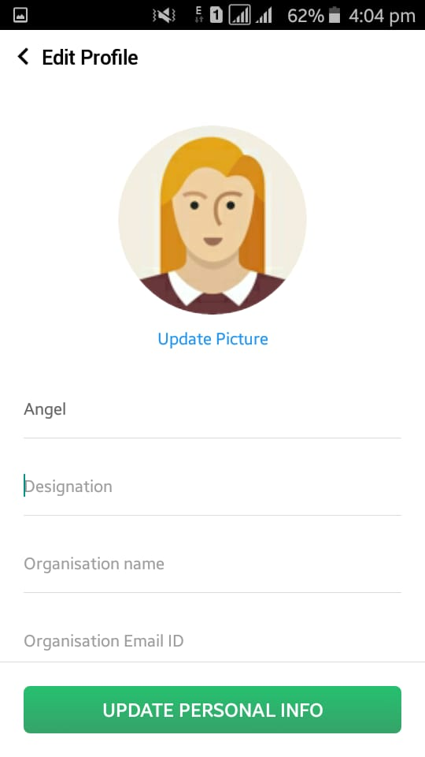

* Profile Verification :

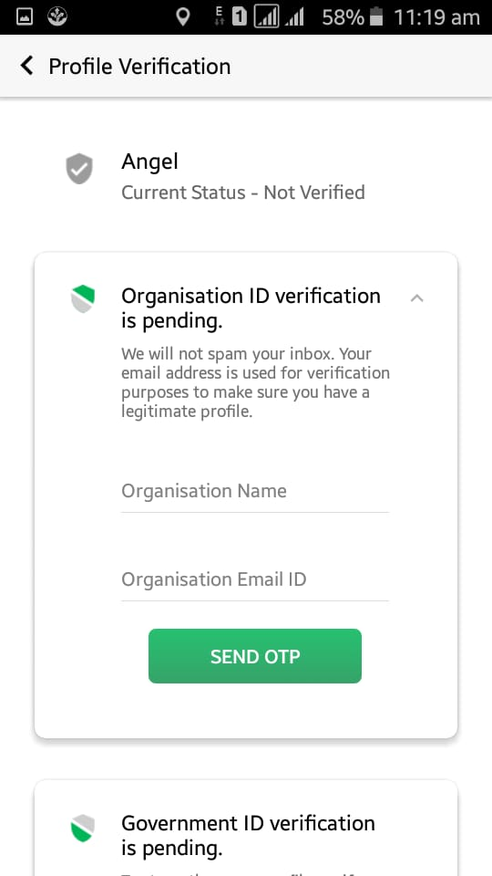

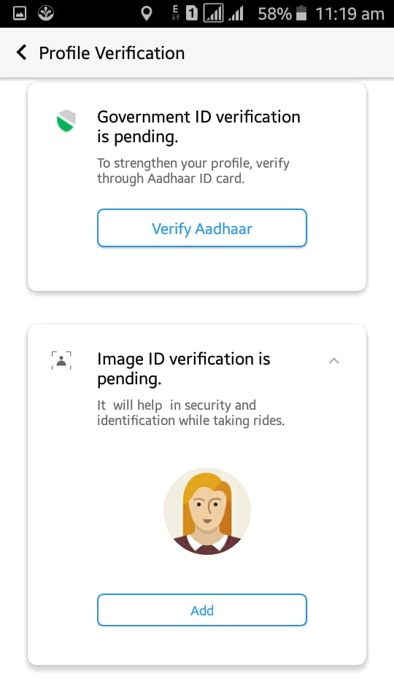

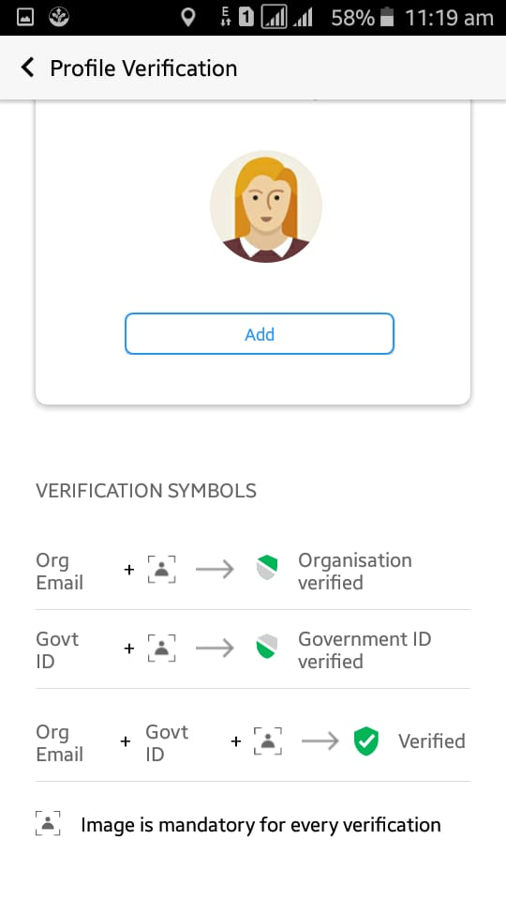

Verify Aadhaar :

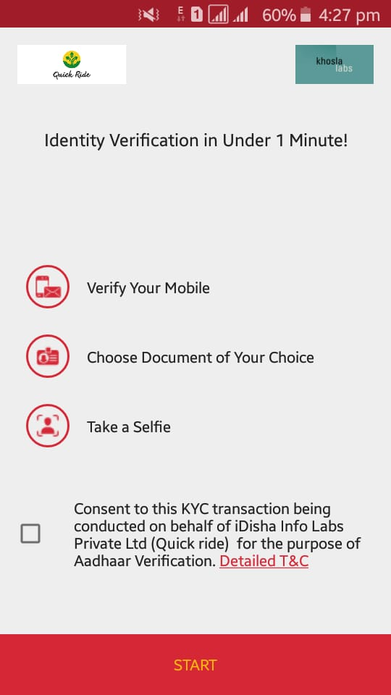

Click start button,

